Георгина Михаилова 201224

Домашна работа 4

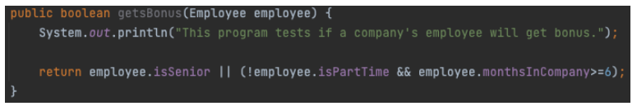1)

Предикат е: employee.isSenior || (!employee.isPartTime && employee.monthsInCompany>=6)

Клаузули се : employee.isSenior, employee.isPartTime, employee.monthsInCompany>=6

2)

a = isSenior

b = isPartTime

c = monthsInCompany>=6

|  |  |  |  |  |  |  |  |
| --- | --- | --- | --- | --- | --- | --- | --- |
|  | a | b | c | a || (!b&&c) | Pa | Pb | Pc |
| 1 | T | T | T | T | T |  |  |
| 2 | T | T | F | T | T |  |  |
| 3 | T | F | T | T |  |  |  |
| 4 | T | F | F | T | T |  |  |
| 5 | F | T | T | F | T | T |  |
| 6 | F | T | F | F | T |  |  |
| 7 | F | F | T | T |  | T | T |
| 8 | F | F | F | F | T |  | T |

CACC :

|  |  |
| --- | --- |
| Major clause | Set of possible tests |
| a | (1,5),(1,6),(1,8),(2,5),(2,6),(2,8),(4,5),(4,6),(4,8) |
| b | (5,7) |
| c | (7,8) |

CACC тесови примерок: 1,5,7,8

RACC:

|  |  |
| --- | --- |
| Major clause | Set of possible tests |
| a | (1,5),(2,6),(4,8) |
| b | (5,7) |
| c | (7,8) |

RACC тестови: 1,5,7,8

